|  |  |  |
| --- | --- | --- |
| **Experiment # 1** | | |
| **Name: Harshit Devadiga** | **Roll No: E015** | **Date of Conduction:- 23/12/2022** |
| **Class:- B. Tech (CSBS)-VI** | | **Division:- E** |

**Aim:**

Create a static web pages using HTML that has

1. Home Page (Your CV)

2. Registration page (Without using form)

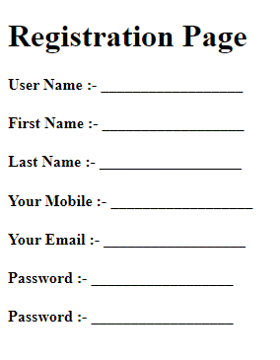

3. Contact Us page (To display address, mobile, email id etc)

**Question 1: - Home Page (Your CV)**

**Create a webpage to display your Curriculum vitae (CV) as per following format with all required entries.**

**MBA TECH/B. TECH. COMPUTER ENGINEERING**

**Name: - Your Name**

**OBJECTIVE:**

Write single line objective

**EDUCATION:**

|  |  |  |  |  |
| --- | --- | --- | --- | --- |
| **Degree** | **Institute** | **Board/University** | **CGPA/Percentage** | **Year** |
| B. Tech |  |  |  | Currently Pursuing |
| XII |  |  |  | 2019 |
| X |  |  |  | 2017 |

**Note: - if X & XII from same institute then use row span in institute column and If board is same for X & XII use row span in Board/University Column.**

**TECHNICAL SKILLS:**

|  |  |
| --- | --- |
| **Domain** | **Details** |
| Languages |  |
| Web Designing |  |
| Software |  |
| Database |  |
| Analytics |  |
| Operating Systems |  |

**KEY PROJECTS:**

|  |  |  |  |
| --- | --- | --- | --- |
| **Project Title** | **Duration** | **Platform Used** | **Brief Description** |
|  |  |  |  |
|  |  |  |  |
|  |  |  |  |

**TECHNICAL –PRESENTATION/WORKSHOPS/CERTIFICATION**

* Program 1
* Program 2

**TECHNICAL –WORK EXPERIENCE / INTERNSHIPS:**

1. Internship 1
2. Internship 2

**Prerequisites:-**

* NIL

**Outcomes:-**

* Student will know about web browser & how it interprets web pages.
* Students will know about how to execute HTML file
* Students will get idea about basic tags of HTML.
* Students will get idea about how to work with HTML list, table and images.

**Theory:-**

**What is HTML?**

HTML is a language for describing web pages. HTML stands for Hyper Text Markup Language. HTML is a markup language. A markup language is a set of markup tags. The tags describe document content. HTML documents contain HTML tags and plain text. HTML documents are also called web pages.

**HTML Tags**

HTML markup tags are usually called HTML tags. HTML tags are keywords (tag names) surrounded by angle brackets like <html>. HTML tags normally come in pairs like <p> and </p>. The first tag in a pair is the start tag, the second tag is the end tag. The end tag is written like the start tag, with a slash before the tag name. Start and end tags are also called opening tags and closing tags

**HTML Element Syntax**

An HTML element starts with a start tag / opening tag. An HTML element ends with an end tag / closing tag. The element content is everything between the start and the end tag. Some HTML elements have empty content. Empty elements are closed in the start tag. Most HTML elements can have attributes.

**HTML Attributes**

HTML elements can have attributes. Attributes provide additional information about an element. Attributes are always specified in the start tag. Attributes come in name/value pairs like: name="value".

**Its good practice to follow following html format:-**

<!DOCTYPE html>  
<html lang="en-us">  
<head>

<meta charset="utf-8">  
  <title> Title</title>  
</head>  
<body>  
  
</body>  
</html>

**HTML Tags:-**

**List**

* **Unordered List**

An unordered list starts with the **<ul>** tag. Each list item starts with the **<li>** tag.

**Example:**

<ul>  
  <li>Cricket</li>  
  <li>Tennis</li>  
  <li>Hockey</li>  
</ul>

* **Ordered List**

An ordered list starts with the **<ol>** tag. Each list item starts with the **<li>** tag.

**Example:**

<ol>  
  <li>Cricket</li>  
  <li>Tennis</li>  
  <li>Hockey</li>  
</ol>

* **Description List**

**<dl>** tag defines the description list

**<dt>** tag defines the term (name)

**<dd>** tag describes each term

**Example:**

<dl>  
  <dt>Static Web Page</dt>  
  <dd>- Do not change frequently</dd>  
  <dt>Dynamic Web Page</dt>  
  <dd>- Created at run time</dd>  
</dl>

* Nesting of list is also possible.

**Tables**

* An HTML table is defined with the **<table>** tag.
* Each table row is defined with the **<tr>** tag.
* A table header is defined with the **<th>** tag.
* By default, table headings are bold and centered.
* A table data/cell is defined with the **<td>** tag.
* **Example:**

<table >  
  <tr>  
    <th>Firstname</th>  
    <th>Lastname</th>   
    <th>Age</th>  
  </tr>  
  <tr>  
    <td>Sachin</td>  
    <td>Tendulkar</td>   
    <td>40</td>  
  </tr>  
  <tr>  
    <td>Rahul</td>  
    <td>Dravid</td>   
    <td>42</td>  
  </tr>  
</table>

**Cell that Span Many rows (Rowspan)**

<table style="width:100%">  
  <tr>  
    <th>Name:</th>  
    <td>RAM Rao</td>  
  </tr>  
  <tr>  
    <th rowspan="2">Mobile:</th>  
    <td>123456</td>  
  </tr>  
  <tr>  
    <td>654321</td>  
  </tr>  
</table>

**Images**

* Images help to make web page look attractive.
* We should always use images in jpg, gif or png, as browser supports these format.
* HTML images are defined with the **<img>** tag.
* Example

<img src="flower.jpg" alt="W3Schools.com" width="104" height="142">

* The compulsory attribute for <img> tag is **src** to specify URL of the image
  + **alt** stands for Alternate Text – If the browser is not supporting Images it display the value of ALT .
  + **height** and **width** specify the height and width of the image.
* Img also has following attributes
  + Hspace – specifies the amount of space to left and right of image.
  + Vspace – Specifies the amount of space to top and bottom of an image.
  + Border – Specifies border around an image.
  + Align – Defines the alignment of image.
* **Example:-**

<img src="home.jpg" alt="Hill Climbing" hspace=250 vspace=250 border=10 align="right">

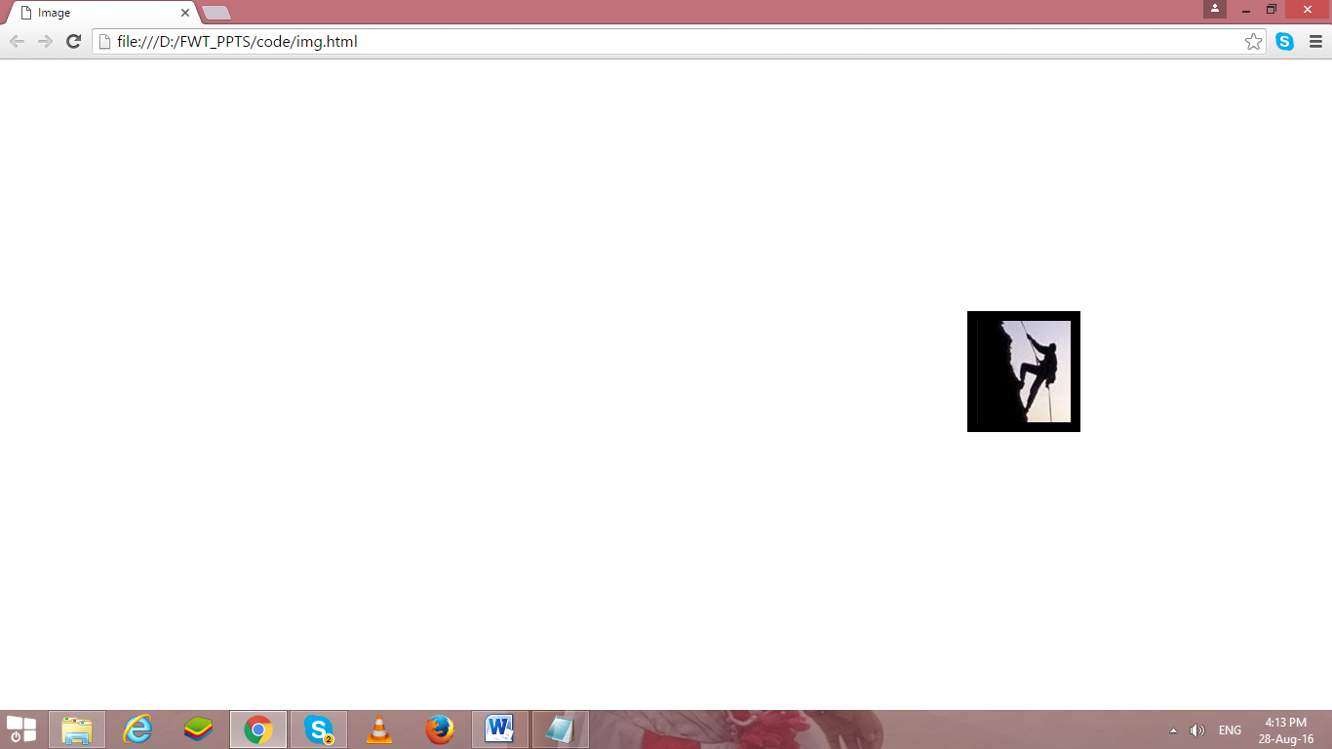

**Instructions:-**

1. Write html code in Note Pad & save with .html extension.
2. Execute using Web Browser.
3. Copy and Paste code as well as output (Print Scrn of output) in Part B

PART: B

Code:

1. **Code Structure:**

1. **Home.html (Homepage: CV)**
2. <!DOCTYPE html>
3. <html lang="en">
4. <head>
5. <meta charset="UTF-8" />
6. <meta http-equiv="X-UA-Compatible" content="IE=edge" />
7. <meta name="viewport" content="width=device-width, initial-scale=1.0" />
8. <title>Home Page</title>
9. </head>
10. <body>
11. <p align="center">
12. <a href="Home.html" target="_blank" rel="noopener noreferrer">Home</a>
13. &nbsp
14. <a href="Registration.html" target="_blank" rel="noopener noreferrer"
15. >Registration</a
16. >
17. &nbsp
18. <a href="Contact Us.html" target="_blank" rel="noopener noreferrer"
19. >Contact Us</a
20. >
21. </p>
22. <div align="center">
23. <img src="nmims.png" alt="nmims" width="10%" />
24. <br />
25. <br />
26. <p><strong>BTECH COMPUTER SCIENCE AND BUSINESS SYSTEMS</strong></p>
27. </div>
28. <h3>Name: Harshit Devadiga</h3>
29. <br /><br />
30. <h3><u>Objective:</u></h3>
31. <p>
32. Lorem ipsum dolor sit amet, consectetur adipiscing elit, sed do eiusmod
33. tempor incididunt ut labore et dolore magna aliqua. Ut enim ad minim
34. veniam, quis nostrud exercitation ullamco laboris nisi ut aliquip ex ea
35. commodo consequat.
36. </p>
37. <h2><u>EDUCATION:</u></h2>
38. <table border="1px solid black" cellspacing="0" cellpadding="5px">
39. <tr>
40. <td><strong>Degree</strong></td>
41. <td><strong>Institute</strong></td>
42. <td><strong>Board/University</strong></td>
43. <td><strong>CGPA/Percentage</strong></td>
44. <td colspan="2"><strong>Year</strong></td>
45. </tr>
46. <tr>
47. <td>BTech</td>
48. <td>MPSTME</td>
49. <td>NMIMS</td>
50. <td>3.57</td>
51. <td>2020</td>
52. <td>2024</td>
53. </tr>
54. <tr>
55. <td>XII</td>
56. <td>Chandrabhan Sharma College</td>
57. <td rowspan="2">Maharashtra</td>
58. <td>82%</td>
59. <td>2018</td>
60. <td>2020</td>
61. </tr>
62. <tr>
63. <td>X</td>
64. <td>Pawar Public School, Chandivali</td>
65. <td>89%</td>
66. <td>2018</td>
67. </tr>
68. </table>
69. <h2><u>TECHNICAL SKILLS:</u></h2>
70. <table border="2px solid black" cellspacing="0" cellpadding="5px">
71. <tr>
72. <td><strong>Degree</strong></td>
73. <td><strong>Institute</strong></td>
74. </tr>
75. <tr>
76. <td>Languages</td>
77. <td>Python,C,C++</td>
78. </tr>
79. <tr>
80. <td>Web Designing</td>
81. <td>Canva, Figma, CSS</td>
82. </tr>
83. <tr>
84. <td>Software</td>
85. <td>Star UML, VS Code</td>
86. </tr>
87. <tr>
88. <td>Database</td>
89. <td>MongoDB, MySQL</td>
90. </tr>
91. <tr>
92. <td>Analytics</td>
93. <td>Pandas</td>
94. </tr>
95. <tr>
96. <td>Operating Systems</td>
97. <td>Linux</td>
98. </tr>
99. </table>
100. <br />
101. <br />
102. <h2>KEY PROJECTS:</h2>
103. <table border="2px solid black" cellspacing="0" cellpadding="5px">
104. <tr>
105. <td>Year</td>
106. <td>Project Title</td>
107. <td>Software</td>
108. <td>Brief Description</td>
109. </tr>
110. <tr>
111. <td>2021</td>
112. <td>Cargo Management System</td>
113. <td>C++ (Object Oriented Programming), HTML, CSS,</td>
114. <td>
115. Created an interface for Cargo management system using HTML and CSS.
116. Also implemented booking system of cargo using C++.
117. </td>
118. </tr>
119. <tr>
120. <td>2021</td>
121. <td>MLR on Spotify music recommendation system</td>
122. <td>Python, Matplotlib, Numpy, Pandas, Sklearn.</td>
123. <td>
124. Multiple Linear Regression on analysis of Spotify music recommendation
125. system based on parameters such as energy, liked, mode, valence and
126. instrumentalness.
127. </td>
128. </tr>
129. </table>
130. <h3>TECHNICAL-PRESENTATION/WORKSHOPS/CERTIFICATION</h3>
131. <h4>Program 1: HTML, CSS, and Javascript for Web Developer, Angela yu</h4>
132. <h4>Program 2: Python for everyone, Coursera</h4>
133. <br />
134. <h3>TECHNICAL-PRESENTATION/WORKSHOPS/CERTIFICATION</h3>
135. <h4>Internship 1: Django Internship at Infytech Bangalore, India</h4>
136. <h4>Internship 2: Full Stack Web Development Intern at Directi, Bangalore</h4>
137. </body>
138. </html>

**3. Registration Page:**

<!DOCTYPE html>

<html lang="en">

  <head>

    <meta charset="UTF-8" />

    <meta http-equiv="X-UA-Compatible" content="IE=edge" />

    <meta name="viewport" content="width=device-width, initial-scale=1.0" />

    <title>Registration Page</title>

  </head>

  <body>

    <div align="center">

      <table cellspacing="15">

        <tr>

          <td>

            <h2>

              <a href="Home.html" rel="noopener noreferrer">Home</a>

            </h2>

          </td>

          <td>

            <h2>

              <a

                href="Registration.html"

                target="_blank"

                rel="noopener noreferrer"

                >Registration Page</a

              >

            </h2>

          </td>

          <td>

            <h2>

              <a

                href="Contact Us.html"

                target="_blank"

                rel="noopener noreferrer"

                >Contact Us</a

              >

            </h2>

          </td>

        </tr>

      </table>

    </div>

    <div align="center">

      <img width="200" src="nmims.png" alt="" />

    </div>

    <h2>Registration</h2>

    <h4>User Name: &nbsp __________________________________</h4>

    <h4>First Name: &nbsp __________________________________</h4>

    <h4>Last Name: &nbsp __________________________________</h4>

    <h4>Your Mobile: &nbsp __________________________________</h4>

    <h4>Your Email: &nbsp __________________________________</h4>

    <h4>Password: &nbsp __________________________________</h4>

    <h4>Confirm Password: &nbsp __________________________________</h4>

  </body>

</html>

1. **Contact Us Page:**
2. <!DOCTYPE html>
3. <html lang="en">
4. <head>
5. <meta charset="UTF-8" />
6. <meta http-equiv="X-UA-Compatible" content="IE=edge" />
7. <meta name="viewport" content="width=device-width, initial-scale=1.0" />
8. <title>Contact Us</title>
9. </head>
10. <body>
11. <div align="center">
12. <table cellspacing="15">
13. <tr>
14. <td>
15. <h2>
16. <a href="Home.html" rel="noopener noreferrer">Home</a>
17. </h2>
18. </td>
19. <td>
20. <h2>
21. <a
22. href="Registration.html"
23. target="_blank"
24. rel="noopener noreferrer"
25. >Registration Page</a
26. >
27. </h2>
28. </td>
29. <td>
30. <h2>
31. <a
32. href="Contact Us.html"
33. target="_blank"
34. rel="noopener noreferrer"
35. >Contact Us</a
36. >
37. </h2>
38. </td>
39. </tr>
40. </table>
41. </div>
42. <div align="center">
43. <img width="200" src="nmims.png" alt="" />
44. </div>
45. <h1>My Contact Details</h1>
46. <ul>
47. <li><h3>Address</h3></li>
48. <p>Powai, Mumbai</p>
49. <li><h3>Email</h3></li>
50. <p>
51. <a href="https://mail.google.com/mail/u/0/"
52. >harshitdevadiga.10@gmail.com
53. </a>
54. </p>
55. <li><h3>Phone Number</h3></li>
56. <p>9930412849</p>
57. </ul>
58. </body>
59. </html>

**Output:**

1. **Homepage**

1. **Registration Page**

**Contact Us Page**

